**Buffon’s Needle Problem and an Extension with Concentric Circles**

Mathematics

Word count: 3500

**Contents**

Introduction 3

Classic Needle Problem 4

Short Needle 5

Separation Distance 5

Orientation 6

Long Needle 8

Solution 9

Concentric Circles 10

Case 1 11

Case 1a 13

Case 1b 15

Case 2 19

Case 2a 20

Case 2b 23

Solution 26

Conclusion 29

Bibliography 31

Appendix 32

Riemann Sum Verification 32

Simulation 33

# Introduction

French nobleman Georges Louis Leclerc, Comte de Buffon was one of the first scholars to explore the area of mathematics known as geometric probability. In 1733 during a lecture at the Royal Academy of Sciences in Paris, he posed his famous needle problem which asked:

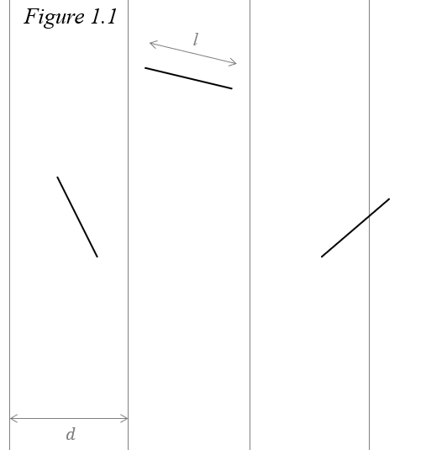Suppose that you drop a needle of length $l$ on ruled paper with lines at a constant interval $d$—what is then the probability that the needle comes to lie in a position where it crosses one of the lines?[1]

In 1777, Buffon answered this question in his *Essai d'arithmétique morale*.[2] Since then, many variations to the needle problem have been proposed and solved. This essay will answer the classic needle problem along with an extension of the problem where the parallel lines are replaced with concentric circles:

What is the probability a needle of length $l$ will cross a circumference when dropped on a set of $N$ concentric circles, given that each circle’s radius varies by a constant amount $d$ and $l≤d$?

# Classic Needle Problem

First, let us establish a few definitions for clarity.

*Position -* the needle is assumed to be a one-dimensional line segment. Its position is the midpoint this line. Denoted $M$.

*Separation distance -* the shortest distance between the closest parallel line and the position of the needle. It is equal to the length of the shortest line connecting $M$ and the nearest parallel line. Denoted $x$.

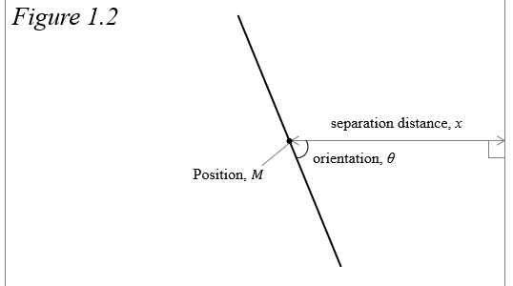*Orientation -* refers to the smaller of the two angles formed between the needle and the line segment representing separation distance. Denoted $θ$ and $0≤θ≤\frac{π}{2}$.

There are two factors to consider when trying to solve Buffon’s needle problem: where the needle lands in relation to the lines, and how it is oriented. We are assuming that the needle is dropped completely randomly, so $M$ is equally likely to be at every point on the plane, and every value of $θ$ is equally likely to occur. With these assumptions, let us find the probability density functions (pdf) of $x$ and $θ$.

Imagine the plane on which the needle is falling is a coordinate plane and the parallel lines are vertical. In this situation, changes in $x$ alter the range of values of $θ$ that will result in a success; as $x$ decreases, this range grows, and as $x$ increases, this range shrinks. Since the lines are perfectly straight and extend infinitely, a change in the y-coordinate does not change $x$, so the y-coordinate does not affect the probability of a success and can therefore be ignored. Because $M$ is equally likely to fall anywhere, each value of $x$ is equally likely, meaning that the pdf of $x$, $f\left(x\right)$, is uniform. The needle is farthest from either line when $M$ is in the middle of two lines, and closest when it is directly on a line, so $x$ is in the interval $\left[0,d/2\right]$.

$$\begin{aligned}f\left(x\right)=\frac{2}{d}, 0≤x≤\frac{d}{2} \#\left(1.1\right)\end{aligned}$$

The range of the values of $θ$ is restricted to the interval $\left[0, π/2\right]$ because it represents all the unique possiblities of how the needle is oriented. As mentioned earlier, each value in this interval is equally likely to occur so the pdf of $θ$, $f\left(θ\right)$, is also uniform:

$$\begin{aligned}f\left(θ\right)=\frac{2}{π} , 0≤θ≤\frac{π}{2} \#\left(1.2\right)\end{aligned}$$

Also, the orientation of the needle has no effect on its position and vice versa, so these variables can be considered independent.

Finally, we must discern between a long needle where $l>d$ and a short needle where $l<d$ because it is possible for a long needle to land on a line at any $x$, but this is not the case for a short needle. As such, the two possibilities lead to different solutions. Call $C_{S}$ the event that a short needle crosses the line and $C_{L}$ the event a long needle crosses the line.

## Short Needle

A short needle needs to land both close enough to the line and have the correct orientation for $C_{S}$ to occur. Call these events $D_{S}$ and $O_{S}$ respectively. Since these events are based on $x$ and $θ$, and the variables are independent, the events are also independent. This means that we can solve for the probability of a short needle success by multiplying the probability the needle lands close enough to a line and the probability it is correctly oriented.

$$\begin{aligned}P\left(C_{S}\right)=P\left(D_{S}∩O_{S}\right)=P\left(D_{S}\right)∙P\left(O_{S}\right)\#\left(1.3\right)\end{aligned}$$

### Separation Distance

The range of values of $x$ is $0≤x≤d/2$. A success occurs at an $x$ value small enough so that the needle is close enough to cross a line. Since the needle’s position is measured at its midpoint, a success occurs when $x<l/2$. To find the probability $D_{S}$ is a success, we can simply divide the range of values of $x$ which yield a success by the total range of values.

$$\begin{aligned}P\left(D_{S}\right)=\frac{\frac{l}{2}-0}{\frac{d}{2}-0}=\frac{l}{2}∙\frac{2}{d}=\frac{l}{d} \#\left(1.4\right)\end{aligned}$$

### Orientation

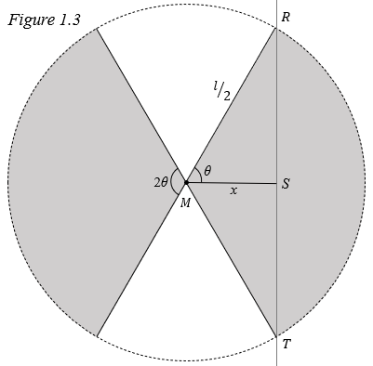To find the probability $O_{S}$ is a success, let us first look at the probability that at a fixed $x$, the needle will cross the line, assuming $x<l/2$. Because $x$ is kept constant, we can imagine the needle is fixed at its midpoint but is free to rotate about this point. When rotated, the needle traces out a circle with center $M$ and radius $l/2$ which represents every possible position the needle can be oriented. The circle intersects the line at two points; call these $R$ and $T$. Drawing lines from these points through $M$ forms two sectors in which the needle must fall for a success, represented by the shaded regions in *figure 1.3*. The “head” of the needle can lie in either sector because if it does not cross the line, its “tail” will. We can divide the area of the two sectors by the total area of the circle to find the probability the needle falls in either sector.

$$\begin{aligned}P=\frac{2∙ \frac{1}{2}r^{2}2θ}{πr^{2}}=\frac{2θ}{π}, 0≤θ≤\frac{π}{2}\#\left(1.5\right)\end{aligned}$$

The shortest distance from a line to a point is formed a line by a perpendicular to the original line so ∠RSM is a right angle. Therefore, the inverse cosine can be used to find *θ*:

$${θ=cos}^{-1}\left(\frac{ x }{\frac{l}{2}}\right)$$

$$\begin{aligned}θ=\cos^{-1}\left(\frac{2x}{l}\right) \#(1.6)\end{aligned}$$

Substituting into $(1.5)$:

$$\begin{aligned}P=\frac{2\cos^{-1}\left(\frac{2x}{l}\right) }{π}, 0≤x≤\frac{l}{2} \#\left(1.7\right)\end{aligned}$$ This equation gives the probability that a short needle of length $l$ crosses $\overline{RT}$ at some value of $x$. If $x>l/2$, then the probability that the needle crosses is 0. Now, to find $P\left(O_{S}\right)$, we must find the *typical* probability that a needle dropped randomly between 0 and $l/2$ units from a line is oriented so that it crosses. To do this, we can take the average probability of $(1.7)$.

$$\begin{aligned}P\left(O_{S}\right)=\frac{1}{l/2-0}\int_{0}^{\frac{l}{2}}{ \frac{2\cos^{-1}\left(\frac{2x}{l}\right) }{π}}dx \end{aligned}$$

$$=\frac{2}{l}∙ \frac{2}{π}\int_{0}^{\frac{l}{2}}{ \cos^{-1}\left(\frac{2x}{l}\right)}dx$$

Substituting $u={2x}/l$ and $du=2/ldx$ and changing the bounds to be in terms of *u*:

$$\begin{aligned}= \frac{4}{lπ}\int_{0}^{1}{ \frac{l\cos^{-1}\left(u\right)}{2}}du \end{aligned}$$

$$=\frac{2}{π}\int_{0}^{1}{\cos^{-1}\left(u\right)}du$$

Integrating by parts:

$$=\frac{2}{π} \left(u\cos^{-1}{u}-\int_{0}^{1}{-\frac{u}{\sqrt{1-u^{2}}}}du\right)$$

Looking just at the integral, we can substitute $v=1-u^{2}$ and $dv=-2udu$. We will not change the bounds to be in terms of $v$ because $u$ will eventually be substituted back in.

$$\int_{0}^{1}{-\frac{u}{\sqrt{1-u^{2}}}}du=\int_{0}^{1}{-\frac{u}{-2u\sqrt{v}}}dv$$

$$=\frac{1}{2}\int_{0}^{1}{\frac{1}{\sqrt{v}}}dv$$

$$=\frac{1}{2} {\left.\left(2\sqrt{v}\right)\right|}_{0}^{1}$$

Substituting *u*:

$$\frac{1}{2} {\left.\left(2\sqrt{v}\right)\right|}_{0}^{1}={\left.\left(\sqrt{1-u^{2}}\right)\right|}_{0}^{1}$$

Replacing the integral with ${\left.\left(\sqrt{1-u^{2}}\right)\right|}_{0}^{1}$:

$$\frac{2}{π} \left(u\cos^{-1}{u}-\int_{0}^{1}{-\frac{u}{\sqrt{1-u^{2}}}}du \right)= \frac{2}{π} {\left.\left(u\cos^{-1}{u-\sqrt{1-u^{2}}}\right)\right|}_{0}^{1}$$

$$= \frac{2}{π} \left[\left(1\cos^{-1}\left(1\right)-\sqrt{1-1^{2}}\right)-\left(0\cos^{-1}\left(0\right)-\sqrt{1-0^{2}}\right)\right]$$

$$=\frac{2}{π} \left[\left(0-0\right)-\left(0-1\right)\right]$$

$$\begin{aligned}P\left(O_{S}\right)=\frac{2}{π} \#\left(1.8\right)\end{aligned}$$

Now we can multiply our two probabilities to find the probability of $C_{S}$.

$$\begin{aligned}P\left(C_{S}\right)=P\left(D_{S}\right)∙P\left(O_{S}\right)\end{aligned}$$

$$=\frac{l}{d}∙\frac{2}{π}$$

$$\begin{aligned}P\left(C_{S}\right)=\frac{2l}{πd} \#\left(1.9\right)\end{aligned}$$

## Long Needle

When $l>d$, the needle will be able to cross a line at any value of $x$, so we only need to address $θ$. Similar to the method for the short needle, we can find the average of $(1.7)$ to find the probability of $C_{L}$. The only difference is that we instead find the average on the interval $\left[0,d/2\right]$ because again, the needle is long enough to cross a line at every value of $x$.

$$\begin{aligned}P\left(C_{L}\right)=\frac{1}{d/2-0}\int_{0}^{\frac{d}{2}}{ \frac{2\cos^{-1}\left(\frac{2x}{l}\right) }{π}}dx\end{aligned}$$

$$=\frac{2}{d}∙\frac{2}{π}\int_{0}^{\frac{d}{2}}{ \cos^{-1}\left(\frac{2x}{l}\right)}dx$$

Substituting $u=\frac{2x}{l}$ and $du=\frac{2}{l}dx$ and changing the bounds to be in terms of *u*:

$$=\frac{4}{πd}∙\frac{l}{2}\int_{0}^{\frac{d}{l}}{\cos^{-1}\left(u\right)}du$$

Integrating by parts:

$$=\frac{2l}{πd} \left(u\cos^{-1}{u}-\int_{0}^{\frac{d}{l}}{-\frac{u}{\sqrt{1-u^{2}}}}du \right)$$

Simplifying in the same manner as $(1.8)$:

$$\frac{2l}{πd}\left( u\cos^{-1}{u}-\int_{0}^{\frac{d}{l}}{-\frac{u}{\sqrt{1-u^{2}}}}du \right)=\frac{2l}{πd}{\left.\left(u\cos^{-1}{u-\sqrt{1-u^{2}}}\right)\right|}_{0}^{\frac{d}{l}}$$

$$=\frac{2l}{πd} \left[\left(\frac{d}{l}\cos^{-1}\left(\frac{d}{l}\right)-\sqrt{1-{\left(\frac{d}{l}\right)}^{2}}\right)-\left(0\cos^{-1}\left(0\right)-\sqrt{1-0^{2}}\right)\right]$$

$$\begin{aligned}P\left(C_{L}\right)=\frac{2l}{πd}\left(\frac{d}{l}\cos^{-1}\left(\frac{d}{l}\right)-\sqrt{1-{\left(\frac{d}{l}\right)}^{2}}+1\right) \#\left(1.10\right)\end{aligned}$$

## Solution

Call $C$ the event where a needle of length $l$ will cross a line, given a floor with equally spaced parallel lines a distance $d$ apart. The probability of $C$ is a combination of the probabilities of $C_{S}$ and $C_{L}$:

$$\begin{aligned}P(C)=\left\{\begin{aligned} \frac{2l}{πd} for l≤d \\ \frac{2l}{πd}\left(\frac{d}{l}\cos^{-1}\left(\frac{d}{l}\right)-\sqrt{1-{\left(\frac{d}{l}\right)}^{2}}+1\right) for l>d\end{aligned}\right. \#\left(1.11\right)\end{aligned}$$

Notice that when $l=d$, the expression in the parenthesis simplifies to $1$ and the solution for a long needle becomes the same as the solution for a short needle, so either solution works in this case.

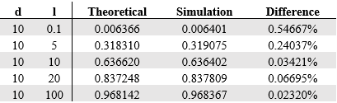To verify this solution, several values of $l$ and $d$ can be selected and used to compare the theoretical probability output by the equation to the empirical probability. Rather than perform the trials myself, I coded a simulation to do them.[3] I tested several different ratios of $l:d$ and one million drops were performed at each. Here are the results:

The slight difference between the theoretical probability and its respective empirical probability are simply due to chance, so my solution is correct.

# Concentric Circles

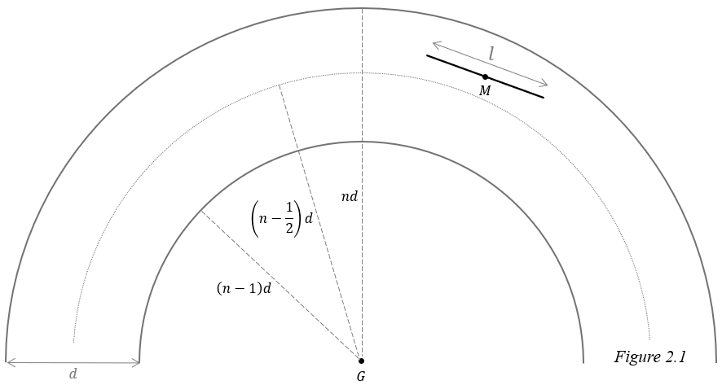To solve this extension, I am referring to a method devised by Harry J. Khamis.[4] As for definitions and assumptions, first, the terms defined previously still apply, but separation distance now refers to the length of the normal line connecting $M$ and the nearest circumference. Second, we will continue to assume $M$ falls at a random spot, $θ$ is random, and the two are independent of each other. Third, we define the center of the circles to be point $G$, and say that the needle falls within the $n^{th}$ annulus with inner radius $\left(n-1\right)d$ and outer radius $nd$.

We will first look at only one annulus and consider the probability a needle crosses either circumference. From the perspective of the needle, the inner circumference is convex while the outer is concave. This difference means the scenario where the needle crosses the outer circumference must be approached differently than the scenario where it crosses the inner circumference. As such, we will separate the problem into two cases.

*Case 1*: The needle falls in the outer half of the $n^{th}$ annulus. Call this event $K_{n}$.

$$\left(n-\frac{1}{2}\right)d<\overline{GM}≤nd, n=1, 2, 3, …,N$$

*Case 2*: The needle falls in the inner half of the $n^{th}$ annulus. Call this event ${K^{'}}_{n}$.

$$\left(n-1\right)d<\overline{GM}≤\left(n-\frac{1}{2}\right)d, n=2, 3, 4, …, N$$

## Case 1

One important difference from the classic needle problem is that the pdf of $x$ is not uniform. This becomes clear if we imagine a circle divided into several annuli. The outermost annulus has the greatest area and since it is assumed the needle is equally likely to land at each point on the circle, it is most likely to land in the outermost annulus. By the same logic, it is least likely to land in the innermost annulus. The farther out an annulus is the greater its area and the likelier the needle is to land there, so we can conclude the needle is more likely to land closer to a circle’s circumference rather than closer to its center, and smaller values of $x$ are more likely to occur.

To find the pdf of $x$ we will first find the cumulative distribution function (cdf) of $x$, $F\left(x\right),$ then differentiate it with respect to $x$. The cdf can be found by calculating the probability that the needle falls a distance between 0 and $x$ from the $n^{th}$ circumference. This is done by dividing the area of the annulus with outer radius $nd$ and inner radius $nd-x$ by the entire area where the needle can land. Since we are assuming the needle lands in the outer half of annulus $n$, this area is formed by an annulus with inner radius $\left(n-1/2\right)d$ and outer radius $nd$.

$$\begin{aligned}F\left(x\right)=\frac{π{\left(nd\right)}^{2}-π{\left(nd-x\right)}^{2}}{π{\left(nd\right)}^{2}-π{\left[\left(n-\frac{1}{2}\right)d\right]}^{2}} \#\left(2.1\right)\end{aligned}$$

Differentiating to find $f\left(x\right)$:

$$\begin{aligned}f\left(x\right)=\frac{d}{dx}\left(\frac{π{\left(nd\right)}^{2}-π{\left(nd-x\right)}^{2}}{π{\left(nd\right)}^{2}-π{\left[\left(n-\frac{1}{2}\right)d\right]}^{2}}\right)\end{aligned}$$

$$=\frac{π}{π{\left(nd\right)}^{2}-π{\left(nd-\frac{d}{2}\right)}^{2}}∙\frac{d}{dx}\left[{\left(nd\right)}^{2}-{\left(nd-x\right)}^{2}\right]$$

$$=\frac{1}{{\left(nd\right)}^{2}-{\left(nd-\frac{d}{2}\right)}^{2}}∙\left(0-2\left(nd-x\right)∙-1\right)$$

$$=\frac{2\left(nd-x\right)}{{\left(nd\right)}^{2}-{\left(nd-\frac{d}{2}\right)}^{2}}$$

$$=\frac{2\left(nd-x\right)}{n^{2}d^{2}-\left(n^{2}d^{2}-nd^{2}+\frac{d^{2}}{4}\right)}$$

$$=\frac{2\left(nd-x\right)}{nd^{2}-\frac{d^{2}}{4}}$$

$$=\frac{2\left(nd-x\right)}{d^{2}\left(n-\frac{1}{4}\right)}$$

$$\begin{aligned}f\left(x\right)=\frac{8\left(nd-x\right)}{d^{2}\left(4n-1\right)}, 0≤x≤\frac{d}{2} \#\left(2.2\right)\end{aligned}$$

The needle is still assumed to have a random orientation, so the pdf of $θ$ is unchanged:

$$\begin{aligned}f\left(θ\right)=\frac{2}{π}, 0≤θ≤\frac{π}{2} \#\left(2.3\right)\end{aligned}$$

### Case 1a

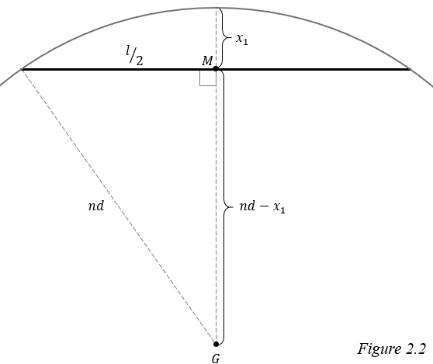In case 1, the needle lands in the outer half of the annulus, so the nearest circumference appears concave. This means there is a special case where the needle is close enough to always cross the circumference, regardless of $θ$. This is clear if we imagine the needle is a chord of a circle. In this scenario, the needle touches the circumference at every orientation.

We will call this critical distance at which this special case occurs $x_{1}$. If $x<x_{1}$, then the probability the needle crosses is 1. We can apply the Pythagorean theorem to solve for $x_{1}$:

$$\begin{aligned}{\left(nd-x_{1}\right)}^{2}+{\left(\frac{l}{2}\right)}^{2}={\left(nd\right)}^{2} \\ {\left(nd-x_{1}\right)}^{2}={\left(nd\right)}^{2}-{\left(\frac{l}{2}\right)}^{2} \\ nd-x_{1}=\sqrt{n^{2}d^{2}-\frac{l^{2}}{4}} \\ x_{1}=nd-\sqrt{n^{2}d^{2}-\frac{l^{2}}{4}} \#(2.4)\end{aligned}$$

Let $C_{n}$ be the event where a needle crosses a circumference when dropped in annulus $n$.

$$\begin{aligned}P\left(C_{n}∩ 0≤x<x_{1}|{ K}_{n}\right)=1∙P\left(0≤x<x_{1}|{ K}_{n}\right) \#\left(2.5\right)\end{aligned}$$

The right side is multiplied by 1 because as mentioned before, when $0≤x<x_{1}$, the probability the needle lands on the circumference is 1. The pdf of $x$ can be integrated to find the probability the needle falls in this range.

$$\begin{aligned}1∙P\left(0≤x<x_{1}\right)=1∙\int_{0}^{x_{1}}{\frac{8\left(nd-x\right)}{d^{2}\left(4n-1\right)}}dx\end{aligned}$$

$$=\frac{8}{d^{2}\left(4n-1\right)}∙\int_{0}^{x_{1}}{nd-x}dx$$

$$=\frac{8}{d^{2}\left(4n-1\right)}\left(nd\left(x_{1}-0\right)-{\left.\left(\frac{x^{2}}{2}\right)\right|}_{0}^{x_{1}}\right)$$

$$=\frac{8}{d^{2}\left(4n-1\right)}\left(ndx_{1}-\left(\frac{{x_{1}}^{2}}{2}-\frac{0^{2}}{2}\right)\right)$$

$$=\frac{8}{d^{2}\left(4n-1\right)}\left(ndx_{1}-\frac{{x_{1}}^{2}}{2}\right)$$

Substituting $x_{1}$:

$$\frac{8}{d^{2}\left(4n-1\right)}\left[nd\left(nd-\sqrt{n^{2}d^{2}-\frac{l^{2}}{4}}\right)-\frac{{\left(nd-\sqrt{n^{2}d^{2}-\frac{l^{2}}{4}}\right)}^{2}}{2}\right]$$

$$=\frac{8}{d^{2}\left(4n-1\right)}\left[nd\left(nd-\frac{\sqrt{{4n^{2}d^{2}-l}^{2}}}{2}\right)-\frac{{\left(nd-\frac{\sqrt{{4n^{2}d^{2}-l}^{2}}}{2}\right)}^{2}}{2}\right]$$

$$=\frac{8}{d^{2}\left(4n-1\right)}\left[nd\left(nd-\frac{\sqrt{{4n^{2}d^{2}-l}^{2}}}{2}\right)-\frac{{\left(2nd-\sqrt{{4n^{2}d^{2}-l}^{2}}\right)}^{2}}{8}\right]$$

$$=\frac{8}{d^{2}\left(4n-1\right)}\left[\frac{8nd\left(nd-\frac{\sqrt{{4n^{2}d^{2}-l}^{2}}}{2}\right)-{\left(2nd-\sqrt{{4n^{2}d^{2}-l}^{2}}\right)}^{2}}{8}\right]$$

Looking at the numerator in the brackets:

$$8nd\left(nd-\frac{\sqrt{{4n^{2}d^{2}-l}^{2}}}{2}\right)-{\left(2nd-\sqrt{{4n^{2}d^{2}-l}^{2}}\right)}^{2}$$

$$=\left(8n^{2}d^{2}-4nd\sqrt{{4n^{2}d^{2}-l}^{2}}\right)-\left(4n^{2}d^{2}-4nd\sqrt{{4n^{2}d^{2}-l}^{2}}+{4n^{2}d^{2}-l}^{2}\right)$$

$$=\left(8n^{2}d^{2}-4nd\sqrt{{4n^{2}d^{2}-l}^{2}}\right)-\left(8n^{2}d^{2}-4nd\sqrt{{4n^{2}d^{2}-l}^{2}}-l^{2}\right)$$

$$=l^{2}$$

Substituting the numerator back in:

$$=\frac{8}{d^{2}\left(4n-1\right)}∙\left(\frac{l^{2}}{8}\right)$$

$$\begin{aligned}P\left(C_{n}∩ 0≤x<x_{1}|{ K}_{n}\right)=\frac{l^{2}}{d^{2}\left(4n-1\right)} \#\left(2.6\right)\end{aligned}$$

### **Case 1b**

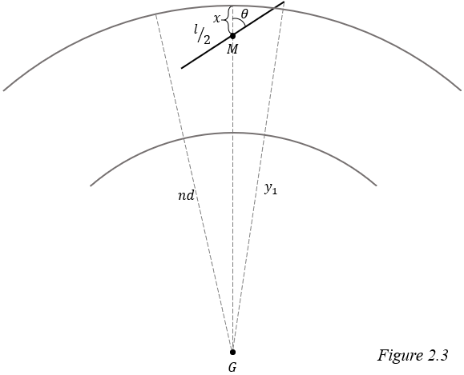Now let us address the scenario where the needle lands outside the critical distance, but still can cross the circumference, $x_{1}<x<l/2$. In this scenario we must also consider $θ$.

To determine whether the needle crosses, we will use the distance from $G$ to the farther endpoint of the needle, call this $y_{1}$. If $y_{1}>nd$ it signifies that the end of the needle is farther from the center of the circle than the circumference. Also, because we are assuming the needle falls within the $n$ th annulus, $\overline{GM}<nd$, so if $y_{1}>nd$, we can conclude the needle has crossed the line. Using the law of cosines to solve for $y_{1}$:

$$\begin{aligned}{y_{1}}^{2}={\left(\frac{l}{2}\right)}^{2}+{\left(nd-x\right)}^{2}-2\left(\frac{l}{2}\right)\left(nd-x\right)\cos\left(π-θ\right)\end{aligned}$$

Applying the identity $\cos\left(π-θ\right) =-\cos{θ}$ and simplifying:

$$y_{1}=±\sqrt{\frac{l^{2}}{4}+{\left(nd-x\right)}^{2}+l\left(nd-x\right)\cos{θ}}$$

We can ignore the negative root because lengths are always positive. Upon substituting $y_{1}$, we have the inequality that must be satisfied for the needle to cross:

$$\sqrt{\frac{l^{2}}{4}+{\left(nd-x\right)}^{2}+l\left(nd-x\right)\cos{θ}}>nd$$

Isolating $θ$:

$$\frac{l^{2}}{4}+{\left(nd-x\right)}^{2}+l\left(nd-x\right)\cos{θ}>{\left(nd\right)}^{2}$$

$$l\left(nd-x\right)\cos{θ}>n^{2}d^{2}-\frac{l^{2}}{4}-{\left(nd-x\right)}^{2}$$

$$\cos{θ}>\frac{n^{2}d^{2}-\frac{l^{2}}{4}-{\left(nd-x\right)}^{2}}{l\left(nd-x\right)}$$

$${-cos}^{-1}\left(\frac{n^{2}d^{2}-\frac{l^{2}}{4}-{\left(nd-x\right)}^{2}}{l\left(nd-x\right)}\right)<θ<\cos^{-1}\left(\frac{n^{2}d^{2}-\frac{l^{2}}{4}-{\left(nd-x\right)}^{2}}{l\left(nd-x\right)}\right)$$

Remember, $0≤θ≤π/2$ so we can ignore the cases where $θ<0$:

$$\begin{aligned}θ<\cos^{-1}\left(\frac{n^{2}d^{2}-\frac{l^{2}}{4}-{\left(nd-x\right)}^{2}}{l\left(nd-x\right)}\right) , x_{1}≤x<l/2 \#\left(2.7\right)\end{aligned}$$

Call the right side of this inequality $α_{1}$. In case 1b, the needle will cross if $θ<α_{1}$.

$$\begin{aligned}P\left(C_{n}∩x_{1}≤x<l/2|{ K}_{n}\right)=P\left(θ<a_{1}∩x_{1}≤x<l/2 |{ K}_{n}\right) \#\left(2.8\right)\end{aligned}$$

The joint pdf of $θ$ and $x$ is necessary to solve $(2.8)$. These variables are independent so we can multiply their pdfs to find the joint pdf.

$$\begin{aligned}f\left(θ,x\right)=f\left(θ\right)∙f\left(x\right)\end{aligned}$$

$$=\frac{2}{π}∙\frac{8\left(nd-x\right)}{d^{2}\left(4n-1\right)}$$

$$\begin{aligned}=\frac{16\left(nd-x\right)}{{πd}^{2}\left(4n-1\right)} \#\left(2.9\right)\end{aligned}$$

We use iterated integrals to solve for the probability because the joint pdf considers both $θ$ and $x$. The inner integral integrates with respect to $θ$, and is bounded by 0 and $α_{1}$ since $θ$ must fall between those values for a cross. Likewise, the outer integral integrates with respect to $x$ and is bounded by $x_{1}$ and $l/2$.

$$\begin{aligned}P\left(x_{1}≤x<\frac{l}{2} ∩ θ<α\right)=\int_{x_{1}}^{\frac{l}{2}}{\int_{0}^{α_{1}}{\frac{16\left(nd-x\right)}{{πd}^{2}\left(4n-1\right)}}dθ}dx\end{aligned}$$

$$=\int_{x_{1}}^{\frac{l}{2}}{\frac{16\left(nd-x\right)}{{πd}^{2}\left(4n-1\right)}\left(a_{1}-0\right)}dx$$

Substituting $α_{1}$:

$$\begin{aligned}P\left(C_{n}∩x_{1}≤x<l/2|{ K}_{n}\right)= \\ \frac{16}{{πd}^{2}\left(4n-1\right)}∙\int_{x_{1}}^{\frac{l}{2}}{\left(nd-x\right)∙\cos^{-1}\left(\frac{n^{2}d^{2}-\frac{l^{2}}{4}-{\left(nd-x\right)}^{2}}{l\left(nd-x\right)}\right) }dx \#\left(2.10\right)\end{aligned}$$

To solve for the probability that a needle crosses a circumference given that it lands in the outer half of annulus $n$ we combine $(2.6)$ and $(2.10)$:

$$\begin{aligned}P\left(C_{n} |{ K}_{n}\right)=P\left(C_{n}∩ 0≤x<x_{1}|{ K}_{n}\right)+P\left(C_{n}∩x_{1}≤x<l/2|{ K}_{n}\right)\end{aligned}$$

$$=\frac{l^{2}}{d^{2}\left(4n-1\right)}+\frac{16}{{πd}^{2}\left(4n-1\right)}∙\int_{x_{1}}^{\frac{l}{2}}{\left(nd-x\right)∙\cos^{-1}\left(\frac{n^{2}d^{2}-\frac{l^{2}}{4}-{\left(nd-x\right)}^{2}}{l\left(nd-x\right)}\right) }dx$$

The calculations of the integral are quite laborious and involved, even running *Wolfram Mathematica* for hours did not yield any results. According to Khamis,[5] this equation can be simplified to:

$$\begin{aligned}P\left(C_{n} |{ K}_{n}\right)=\frac{4}{{πd}^{2}\left(4n-1\right)}∙\left(l\sqrt{n^{2}d^{2}-\frac{l^{2}}{4}}+2n^{2}d^{2}\sin^{-1}\left(\frac{l}{2nd}\right)\right) \#\left(2.11\right)\end{aligned}$$

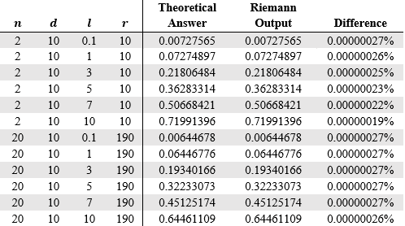To confirm the accuracy of this answer, I created a program to approximate the answer to the integral using Riemann sums.[6] Below there is a table which compares Khamis’s solution and the output of my program at different values of $n$ and different ratios of $d:l$. The difference between the two is negligible, therefore, I believe this answer is correct.

## Case 2

The pdf of $x$ in case 2 differs from case 1 because $x$ is now the distance from $M$ to the inner circumference. To find the pdf of $x$, just as we did in case 1, we first find the cdf of $x$ by dividing the area where the needle is less than $x$ from the ${\left(n-1\right)}^{th}$ circumference by the total area of the inner half of the $n^{th}$ annulus.

$$\begin{aligned}F\left(x\right)=\frac{π{\left(\left(n-1\right)d+x\right)}^{2}-π{\left(n-1\right)d}^{2}}{π{\left[\left(n-\frac{1}{2}\right)d\right]}^{2}-π{\left(n-1\right)d}^{2}}\end{aligned}$$

Set $r=\left(n-1\right)d$:

$$\begin{aligned}=\frac{{\left(r+x\right)}^{2}-r^{2}}{{\left[\left(n-\frac{1}{2}\right)d\right]}^{2}-r^{2}} \#\left(2.12\right)\end{aligned}$$

Then we differentiate to find $f(x)$:

$$\begin{aligned}f\left(x\right)=\frac{d}{dx}\left(\frac{{\left(r+x\right)}^{2}-r^{2}}{{\left[\left(n-\frac{1}{2}\right)d\right]}^{2}-r^{2}}\right)\end{aligned}$$

$$=\frac{1}{{\left(n-\frac{1}{2}\right)}^{2}d^{2}-{\left(n-1\right)}^{2}d^{2}}∙\frac{d}{dx}\left[{\left(r+x\right)}^{2}-r^{2}\right]$$

$$=\frac{1}{d^{2}\left[{\left(n-\frac{1}{2}\right)}^{2}-{\left(n-1\right)}^{2}\right]}∙\left(2\left(r+x\right)∙1-0\right)$$

$$=\frac{2\left(r+x\right)}{d^{2}\left[\left(n^{2}-n+\frac{1}{4}\right)-\left(n^{2}-2n+1\right)\right]}$$

$$\begin{aligned}f\left(x\right)=\frac{2\left(r+x\right)}{d^{2}\left(n-\frac{3}{4}\right)}, 0≤x≤\frac{d}{2} \#\left(2.13\right)\end{aligned}$$

The pdf of $θ$ remains the same, and we can find the joint pdf of $θ$ and $x$ the same way:

$$\begin{aligned}f\left(θ,x\right)=f\left(θ\right)∙f\left(x\right)\end{aligned}$$

$$=\frac{2}{π}∙\frac{2\left(r+x\right)}{d^{2}\left(n-\frac{3}{4}\right)}$$

$$\begin{aligned}f\left(θ,x\right)=\frac{4\left(r+x\right)}{πd^{2}\left(n-\frac{3}{4}\right)} \#\left(2.14\right)\end{aligned}$$

### Case 2a

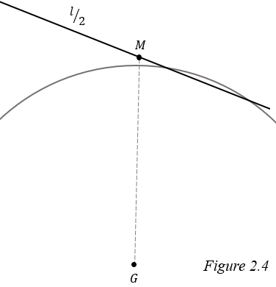In case 1, we compared the distance between $G$ and the farther endpoint of the needle to the distance between $G$ and the $n^{th}$ circumference to find the conditions for a success. This method can be reapplied to case 2, but there is a special case where it fails. Because the needle now lands on the inner half of the annulus, the nearest circumference appears convex. This means it is possible for both endpoints to be outside of the ${\left(n-1\right)}^{th}$ circumference, but still have the needle cross as is shown in *figure 2.4*.

To find where this case occurs, call the maximum value of $x$ at which the needle can be tangent to the ${\left(n-1\right)}^{th}$ circumference $x_{2}$. The radius of a circle forms a right angle with a tangent line so we can apply the Pythagorean theorem.

$$\begin{aligned}{\left(x_{2}+\left(n-1\right)d\right)}^{2}={\left(\frac{l}{2}\right)}^{2}+{\left(\left(n-1\right)d\right)}^{2}\end{aligned}$$

$$x_{2}+r=\sqrt{{\left(\frac{l}{2}\right)}^{2}+r^{2}}$$

$$\begin{aligned}x_{2}=\sqrt{\frac{l^{2}}{4}+r^{2}}-r \#\left(2.15\right)\end{aligned}$$

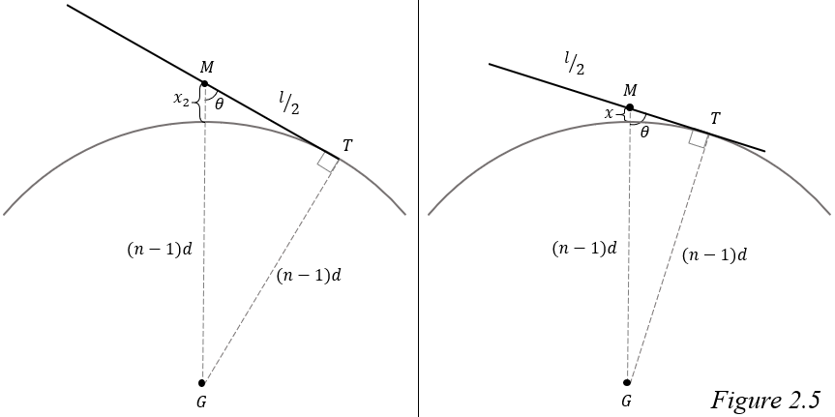When $x=x_{2}$ and the needle is tangent to the ${\left(n-1\right)}^{th}$ circumference, its endpoint touches the circumference, but when $x<x_{2}$ and the needle is tangent, some other point along the needle contacts the circle, call this point $T$.

As seen on the right in *figure 2.5*, $△MTG$ is a right triangle so we can find the value of $θ$ such that the needle is tangent to the circle at $T$.

$$\begin{aligned}\sin{θ}=\frac{r}{r+x}\end{aligned}$$

$$\begin{aligned}θ=\sin^{-1}{\begin{aligned}\left(\frac{r}{r+x}\right) \#\end{aligned}}\end{aligned}$$

At this value of $θ$, the needle touches the circumference at exactly one point, so if $θ$ were to get smaller by any amount, the needle would no longer be tangent and would cross the circumference.

$$\begin{aligned}θ<\sin^{-1}\left(\frac{r}{r+x}\right)\#\left(2.13\right)\end{aligned}$$

Call the right side of this inequality $α_{2a}$.

Just as we did in case 1, we can use an iterated integral to find the probability a needle crosses in this special case:

$$\begin{aligned}P\left(C_{n}∩0<x<x_{2} | {K^{'}}_{n}\right)=P\left(θ<α_{2a}∩0<x<x_{2} | {K^{'}}_{n}\right)\end{aligned}$$

$$=\int_{0}^{x_{2}}{\int_{0}^{α_{2a}}{\frac{4\left(x+r\right)}{πd^{2}\left(n-\frac{3}{4}\right)}}dθ}dx$$

$$=\int_{0}^{x_{2}}{\frac{4\left(x+r\right)}{πd^{2}\left(n-\frac{3}{4}\right)}\left(α_{2a}-0\right)}dx$$

$$=\frac{4}{πd^{2}\left(n-\frac{3}{4}\right)}∙\int_{0}^{x_{2}}{\left(r+x\right)∙\sin^{-1}\left(\frac{r}{r+x}\right)}dx$$

We come across an integral much like the one in case 1. The answer here is:[7]

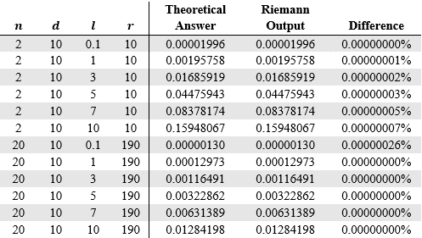Again, I verified this answer.

### Case 2b

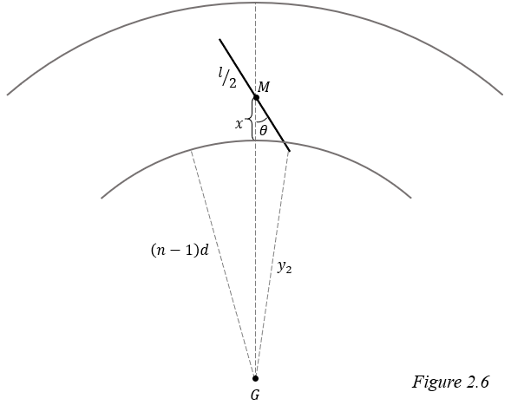When $x_{2}≤x<l/2$, the needle will only cross if its near endpoint is closer to the center than the circumference, so it can be solved in a similar manner as case 1b.

Call the distance from $G$ to the closer endpoint $y_{2}$. If $y_{2}<r$, then the needle has crossed the circumference. Applying the law of cosines to find $y_{2}$:

$$\begin{aligned}{y_{2}}^{2}={\left(\frac{l}{2}\right)}^{2}+{\left(r+x\right)}^{2}-2\left(\frac{l}{2}\right)\left(r+x\right)\cos{θ}\end{aligned}$$

$$y_{2}=±\sqrt{\frac{l^{2}}{4}+{\left(r+x\right)}^{2}-l\left(r+x\right)\cos{θ}}$$

Lengths are always positive, so we ignore the negative root and substitute:

$$\sqrt{\frac{l^{2}}{4}+{\left(r+x\right)}^{2}-l\left(r+x\right)\cos{θ}}<r$$

Isolating $θ$:

$$\frac{l^{2}}{4}+{\left(r+x\right)}^{2}-l\left(r+x\right)\cos{θ}<r^{2}$$

$$-l\left(r+x\right)\cos{θ}<r^{2}-\frac{l^{2}}{4}-{\left(r+x\right)}^{2}$$

$$\cos{θ}>\frac{\frac{l^{2}}{4}+{\left(r+x\right)}^{2}{-r}^{2}}{l\left(r+x\right)}$$

$$-\cos^{-1}{\frac{\frac{l^{2}}{4}+{\left(r+x\right)}^{2}{-r}^{2}}{l\left(r+x\right)}}<θ<\cos^{-1}{\frac{\frac{l^{2}}{4}+{\left(r+x\right)}^{2}{-r}^{2}}{l\left(r+x\right)}}$$

$$\begin{aligned}θ<\cos^{-1}\left(\frac{\frac{l^{2}}{4}+{\left(r+x\right)}^{2}{-r}^{2}}{l\left(r+x\right)}\right) , x_{2}<x<\frac{l}{2} \#\left(2.18\right)\end{aligned}$$

Call the right side of this inequality $α_{2b}$.

Again, we integrate to find the probability a needle crosses when $x_{2}<x<l/2$ and the needle falls in the inner half of the annulus:

$$\begin{aligned}P\left(C_{n}∩x_{2}≤x< \frac{l}{2}| {K^{'}}_{n}\right)=P\left(θ<α_{2b}∩x_{2}≤x< \frac{l}{2} | {K^{'}}_{n}\right)\end{aligned}$$

$$=\int_{x_{2}}^{\frac{l}{2}}{\int_{0}^{α_{2b}}{\frac{4\left(r+x\right)}{πd^{2}\left(n-\frac{3}{4}\right)}}dθ}dx$$

$$=\int_{x_{2}}^{\frac{l}{2}}{\frac{4\left(r+x\right)}{πd^{2}\left(n-\frac{3}{4}\right)}\left(α_{2b}-0\right)}dx$$

Substituting $α_{2b}$:

$$=\frac{4}{πd^{2}\left(n-\frac{3}{4}\right)}∙\int_{x_{2}}^{\frac{l}{2}}{\left(r+x\right)∙\cos^{-1}\left(\frac{\frac{l^{2}}{4}+{\left(r+x\right)}^{2}{-r}^{2}}{l\left(r+x\right)}\right)}dx$$

The answer to this final integral is:[8]

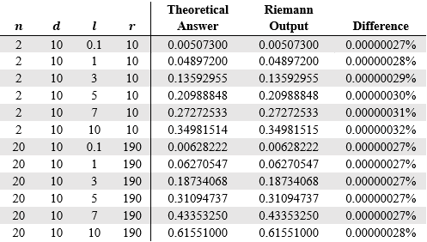Here is the final verification.

We can now solve for the probability of a cross when the needle falls in the inner half of the annulus by combining $(2.17)$ and $(2.19):$

$$\begin{aligned}P\left(C_{n}| {K^{'}}_{n}\right)=P\left(C_{n}∩x_{2}≤x< \frac{l}{2}| {K^{'}}_{n}\right)+P\left(C_{n}∩0<x<x_{2} | {K^{'}}_{n}\right)\end{aligned}$$

$$=\frac{1}{πd^{2}\left(n-\frac{3}{4}\right)}∙\left(r\left(l+πr\right)-\frac{4r^{2}+l^{2}}{2}∙\cos^{-1}\left(\frac{l}{\sqrt{4r^{2}+l^{2}}}\right)\right)+$$

$$\frac{1}{πd^{2}\left(n-\frac{3}{4}\right)}∙\left(r\left(l-πr\right)+\frac{4r^{2}+l^{2}}{2}∙\cos^{-1}\left(\frac{l}{\sqrt{4r^{2}+l^{2}}}\right)\right)$$

$$=\frac{1}{πd^{2}\left(n-\frac{3}{4}\right)}∙$$

$$\left(r\left(l+πr\right)-\frac{4r^{2}+l^{2}}{2}∙\cos^{-1}\left(\frac{l}{\sqrt{4r^{2}+l^{2}}}\right)+r\left(l-πr\right)+\frac{4r^{2}+l^{2}}{2}∙\cos^{-1}\left(\frac{l}{\sqrt{4r^{2}+l^{2}}}\right)\right)$$

$$=\frac{r\left(l+πr\right)+r\left(l-πr\right)}{πd^{2}\left(n-\frac{3}{4}\right)}$$

$$=\frac{r\left(l+πr+l-πr\right)}{πd^{2}\left(n-\frac{3}{4}\right)}$$

$$=\frac{2lr}{πd^{2}\left(n-\frac{3}{4}\right)}$$

Substituting $\left(n-1\right)d$ for $r$:

$$=\frac{2l\left[\left(n-1\right)d\right]}{πd^{2}\left(n-\frac{3}{4}\right)}$$

$$\begin{aligned}P\left(C_{n}| {K^{'}}_{n}\right)=\frac{2l\left(n-1\right)}{πd\left(n-\frac{3}{4}\right)} \#\left(2.20\right)\end{aligned}$$

## Solution

Now that we know the probability of a cross when the needle lands in either the inner or outer half of annulus $n$, we must find the probability that the needle lands in each of these halves. This is done by dividing the area of the respective portion of the annulus by the area of the $N$ th circle.

$$\begin{aligned}P\left(K_{n}\right)=\frac{π{\left(nd\right)}^{2}-π{\left[\left(n-\frac{1}{2}\right)d\right]}^{2}}{π{\left(Nd\right)}^{2}}\end{aligned}$$

$$=\frac{n^{2}d^{2}-{\left(n-\frac{1}{2}\right)}^{2}d^{2}}{N^{2}d^{2}}$$

$$=\frac{n^{2}-\left(n^{2}-n+\frac{1}{4}\right)}{N^{2}}$$

$$P\left(K_{n}\right)=\frac{n-\frac{1}{4}}{N^{2}}$$

$$P\left({K'}_{n}\right)=\frac{π{\left[\left(n-\frac{1}{2}\right)d\right]}^{2}-π{\left[\left(n-1\right)d\right]}^{2}}{π{\left(Nd\right)}^{2}}$$

$$=\frac{{\left(n-\frac{1}{2}\right)}^{2}d^{2}-{\left(n-1\right)}^{2}d^{2}}{N^{2}d^{2}}$$

$$=\frac{\left(n^{2}-n+\frac{1}{4}\right)-\left(n^{2}-2n+1\right)}{N^{2}}$$

$$\begin{aligned}P\left({K^{'}}_{n}\right)=\frac{n-\frac{3}{4}}{N^{2}} \#\left(2.21\right)\end{aligned}$$

Call $C_{N}$ the event where a needle crosses a circumference when dropped on $N$ concentric circles. We can now take our solutions, which apply only to a specific annulus, and generalize them to account for all annuli using the law of total probability. All possible locations of $M$ fall somewhere within the $N$ th circle which we will partition into the inner and outer halves of each annulus. We can then sum the probabilities that the needle crosses the nearest circumference and lands in the inner half of the $n$ th annulus for all $N$ annuli. Doing the same with the outer half of the $n$ th annulus and adding the two sums together provides the probability that the needle crosses any circumference, $P\left(C_{N}\right)$.

$$\begin{aligned}P\left(C_{N}\right)=\sum_{n=1}^{N}{P\left(C_{n}∩ K_{n}\right)}+\sum_{n=2}^{N}{P\left(C_{n}∩{K^{'}}_{n}\right)}\end{aligned}$$

This can be rewritten:

$$\begin{aligned}P\left(C_{N}\right)=\sum_{n=1}^{N}{P\left(C_{n}| K_{n}\right)}∙P\left(K_{n}\right)+\sum_{n=2}^{N}{P\left(C_{n}| {K^{'}}_{n}\right)}∙P\left({K^{'}}_{n}\right)\end{aligned}$$

Left term:

$$\sum_{n=1}^{N}{\frac{4}{{πd}^{2}\left(4n-1\right)}∙\left(l\sqrt{n^{2}d^{2}-\frac{l^{2}}{4}}+2n^{2}d^{2}\sin^{-1}\left(\frac{l}{2nd}\right)\right)∙\frac{n-\frac{1}{4}}{N^{2}}}$$

$$=\sum_{n=1}^{N}{\frac{4\left(n-\frac{1}{4}\right)}{{πd}^{2}N^{2}\left(4n-1\right)}∙\left(l\sqrt{n^{2}d^{2}-\frac{l^{2}}{4}}+2n^{2}d^{2}\sin^{-1}\left(\frac{l}{2nd}\right)\right)}$$

$$=\frac{1}{{πd}^{2}N^{2}}∙\sum_{n=1}^{N}{\left(l\sqrt{n^{2}d^{2}-\frac{l^{2}}{4}}+2n^{2}d^{2}\sin^{-1}\left(\frac{l}{2nd}\right)\right)}$$

Right term:

$$\sum_{n=2}^{N}{\frac{2l\left(n-1\right)}{πd\left(n-\frac{3}{4}\right)}}∙\frac{n-\frac{3}{4}}{N^{2}}$$

$$=\frac{2l}{πdN^{2}}\sum_{n=2}^{N}{n-1}$$

$$=\frac{2l}{πdN^{2}}\left(\sum_{n=1}^{N}{\left(n-1\right)}-\sum_{n=1}^{1}{\left(n-1\right)}\right)$$

$$=\frac{2l}{πdN^{2}}\left(\sum_{n=1}^{N}{\left(n-1\right)}-0\right)$$

$$=\frac{2l}{πdN^{2}}\left(\sum_{n=1}^{N}{n}-\sum_{n=1}^{N}{1}\right)$$

$$=\frac{2l}{πdN^{2}}\left(\frac{N}{2}\left(N+1\right)-N\right)$$

$$=\frac{2l}{πdN^{2}}\left(\frac{N^{2}}{2}-\frac{N}{2}\right)$$

$$=\frac{l\left(N-1\right)}{πdN}$$

The final solution:

$$\begin{aligned}P\left(C_{N}\right)=\frac{1}{{πd}^{2}N^{2}}∙\sum_{n=1}^{N}{\left(l\sqrt{n^{2}d^{2}-\frac{l^{2}}{4}}+2n^{2}d^{2}\sin^{-1}\left(\frac{l}{2nd}\right)\right)}+\frac{l\left(N-1\right)}{πdN} \#\left(2.22\right)\end{aligned}$$

This is the probability that a needle of length $l$ will cross a circumference when randomly dropped on a set of $N$ concentric circles, each spaced a distance $d$ apart, and $l<d$.

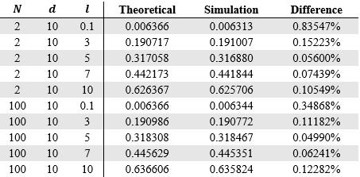I again verified the solution with a simulation.[9] I ran one million trials at two different values of $N$ and several different ratios of $l:d$. Here are the results:

Again, the slight difference between the two probabilities is due to chance, so the solution is correct.

# Conclusion

Of course, there are a variety of methods of solving the classic needle problem, some of which utilize more sophisticated mathematics than my approach. However, I wanted to solve the problem on my own and to me, my method is the most intuitive. I found that the probability that a needle of length $l$ will land on a line, given a floor with equally spaced parallel lines a distance $d$ apart is:

$$\left\{\begin{aligned} \frac{2l}{πd} for l≤d \\ \frac{2l}{πd}\left(\frac{d}{l}\cos^{-1}\left(\frac{d}{l}\right)-\sqrt{1-{\left(\frac{d}{l}\right)}^{2}}+1\right) for l>d\end{aligned}\right.$$

Interestingly, $π$ appears in the solution. Looking just at the solution to the short needle, we can rearrange it:

$$π=\frac{2l}{Pd}$$

This equation can be used to approximate the constant using Monte Carlo methods. In 1850, Johann Rudolf Wolf performed Buffon’s needle problem with 5000 needles which were 36mm long and parallel lines 44mm apart.[10] His experiment yielded the experimental probability 0.5064 which can be substituted into the equation above and results in an approximation of $π$ which is only about 0.57% from the true value.

$$π≈\frac{2\left(36\right)}{\left(0.5064\right)\left(44\right)}$$

$$π≈3.1596$$

There are several popular extensions to the classic needle problem, all of which would be interesting to explore. For example, the Laplace extension to the problem asks for the probability the needle lands on the lines of a regular grid pattern. [11] Buffon’s noodle problem replaces the rigid needle with a flexible “noodle” and asks for the expected number of line crosses. [12] I solved the needle problem with concentric circles and found the probability that a needle of length $l$ will cross a circumference when dropped on a set of $N$ concentric circles, given that each circle’s radius varies by a constant amount $d$ and $l≤d$, to be:

$$\frac{1}{{πd}^{2}N^{2}}∙\sum_{n=1}^{N}{\left(l\sqrt{n^{2}d^{2}-\frac{l^{2}}{4}}+2n^{2}d^{2}\sin^{-1}\left(\frac{l}{2nd}\right)\right)}+\frac{l\left(N-1\right)}{πdN}$$

One further extension to this problem could have the distance between the center of the circles and the position of the needle follow a Gaussian distribution so the needle is likelier to land closer to the center. This more closely resembles a real-world recreation of the problem.

# Bibliography

Aigner, Martin, and Günter M Ziegler. *Proofs from THE BOOK*. Springer-Verlag, 2004.

D-Orrie, Heinrich, et al. *100 Great Problems of Elementary Mathematics: Their History and Solution*. United Kingdom, Dover Publications, 1965.

Hyksova, Magdalena, et al. “Early History of Geometric Probability and Stereology.” *Image Analysis and Stereology*, vol. 31, no. 1, 2012, doi:10.5566/ias.v31.p1-16.

Khamis, Harry J. “On Buffon’s Needle Problem Using Concentric Circles.” *Pi Mu Epsilon Journal*, vol. 8, no. 6, 1987, pp. 368-374. *Pi Mu Epsilon*, http://www.pme-math.org/journal/issues.html

Ramaley, J. F. “Buffon's Noodle Problem.” *The American Mathematical Monthly*, vol. 76, no. 8, 1969, pp. 916–918. *JSTOR*, www.jstor.org/stable/2317945.

Siniksaran, Enis. “Throwing Buffon's Needle with Mathematica.” *The Mathematica Journal*, vol. 11, no. 1, 2011, www.mathematica-journal.com/2009/01/12/throwing-buffons-needle-with-mathematica/.

Weisstein, Eric W. "Buffon's Needle Problem." From *MathWorld*--A Wolfram Web Resource. https://mathworld.wolfram.com/BuffonsNeedleProblem.html

# Appendix

## Riemann Sum Verification

This is program uses midpoint Riemann sums to approximate the integrals noted in the essay which I can use to ensure the answers are correct. All code is written in Java.

public class Verify {

        //variable names correspond with those used in the essay

        static int n = 20;                  //annulus number

        static double d = 10;               //distance between annuli

        static double l = 0.1;              //length of needle

        static double r = (n-1)*d;

        static double x1 = n*d - Math.sqrt(n*n * d*d - l*l / 4);

        static double x2 = Math.sqrt(l*l / 4 + r*r) - r;

    public static void main(String[] args) {

        double case1 = integral1(x1, l/2);

        System.out.println(case1 + (l*l) / (d*d*(4*n - 1)));    //adding the solved integral

        double case2a = integral2a(x2, l/2);

        System.out.println(case2a);

        double case2b = integral2b(0, x2);

        System.out.println(case2b);

    }

    /**

     * Uses midpoint Riemann sums to approximate each respective integral

     *

     * @param lower     lower bound of the integral

     * @param upper     upper bound of the integral

     * @return          area under the curve, an approximation of the definite integral

     */

    public static double integral1(double lower, double upper) {

        double area = 0;                                    // area under the curve

        int rectangles = 100000;                            // number of rectangles

        double width = (upper - lower)/rectangles;          // width of each rectangle

        for (int i = 0; i < rectangles; i++) {

            //calculates x, the x-coordinate of midpoint of the horizontal line of the rectangle

            double x = (i + 0.5) * width + lower;

            //finds f(x), the height of the rectangle

            double height = (n*d - x)*Math.acos((n*n * d*d - (l*l / 4) - (n*d - x)*(n*d - x))/(l*(n*d - x)));

            //multiplies width by height and adds it to area

            area += width*height;

        }

        area *= 16 / ((Math.PI*d*d)*(4*n-1));

        return area;

    }

    public static double integral2a(double lower, double upper) {

        double area = 0;

        int rectangles = 100000;

        double width = (upper - lower)/rectangles;

        for (int i = 0; i < rectangles; i++) {

            double x = (i + 0.5) * width + lower;

            double height = (r + x)*Math.acos((l*l / 4 + (r + x)*(r + x) - r*r)/(l*(r + x)));

            area += width*height;

        }

        area *= 4 / ((Math.PI*d*d)*(n-0.75));

        return area;

    }

    public static double integral2b(double lower, double upper) {

        double area = 0;

        int rectangles = 100000;

        double width = (upper - lower)/rectangles;

        for (int i = 0; i < rectangles; i++) {

            double x = (i + 0.5) * width + lower;

            double height = (r + x)*Math.asin(r / (r+x));

            area += width*height;

        }

        area *= 4 / ((Math.PI*d*d)*(n-0.75));

        return area;

    }

}

## Simulation

This code simulates the needle dropping for the classic needle problem.

public class SimulateClassic {

    //variable names correspond with those used in the essay

    static double d = 10;        //distance between lines

    static double l = 5;        //length of needle

    static int drops = 1000000;

    public static void main(String[] args) {

        int count = 0;

        for(int i=0; i<drops; i++) {

            NeedleClassic needle = new NeedleClassic(l, d);

            if (needle.getX() <= l / 2) {

                if (needle.getTheta() <= Math.acos(2 * needle.getX() / l))

                    count++;

            }

        }

        System.out.println(count);

    }

}

public class NeedleClassic {

    private double x;

    private double theta;

    public NeedleClassic (double l, double d){

        x = Math.random() * d / 2;

        theta = Math.random() * Math.PI / 2;

    }

    public double getX() {

        return x;

    }

    public double getTheta() {

        return theta;

    }

}

This code simulates the needle dropping for the needle problem with concentric circles.

public class SimulateCircles {

    //variable names correspond with those used in the essay

    static int N = 3;               //number of concentric circles

    static double d = 2;            //length of needle

    static double l = 1;            //distance between annuli

    static int drops = 1000000;     //number of drops to simulate

    public static void main(String[] args) {

        int count = 0;      //number of crosses

        for(int i=0; i<drops; i++) {

            NeedleCircles needle = new NeedleCircles(N, d);

            int n = needle.getn();

            double r = (n-1)*d;

            double x = needle.getX();

            double theta = needle.getTheta();

            //outer half test

            if(x < d/2) {

                if (x < l / 2) {

                    if(Math.sqrt((n*d - x)*(n*d - x) + (l*l / 4) +

l*(n*d - x)*Math.cos(theta)) > n*d)

                        count++;

                }

            }

            //inner half test

            else {

                //converts x to distance to inner circumference of annulus

                x = d-x;

                if (x < l/2) {

                    if(x < (Math.sqrt(l*l/4 + r*r)-r)) {

                        if(theta < Math.asin(r / (r+x)))

                            count++;

                    }

                    else {

                        if(Math.sqrt(l*l/4 + (r + x)*(r + x) –

l*(r + x)*Math.cos(theta)) < r)

                            count++;

                    }

                }

            }

        }

        System.out.println(count);

    }

}

public class NeedleCircles {

    //variable names correspond with those used in the essay

    private int N;              //number of concentric circles

    private int n;              //number of annulus where the needle falls

    private double d;           //distance between annuli

    private double x;           //distance from outer circumference of annulus n

    private double theta;       //orientation of needle

    public NeedleCircles (int N, double d){

        this.N = N;

        this.d = d;

        x = generate();

        //generates a pseudo random value for theta

        theta = Math.random() * Math.PI / 2;

    }

    /**

     * Uses inverse transform sampling to generate a random

     * variable with the desired pdf.

     * Takes a pdf then find the inverse of its cdf

     * Inserts a uniform random variable on the interval

     * [0,1] into the cdf

     * (note that Math.random() generates on the

     * interval [0,1) and is not truly random, but for

     * our purposes it is sufficient)

     * @return a random number with the desired pdf

     */

    private double generate() {

        //generates distance away from center using an inverse cdf

        double GM = N*d*Math.sqrt(Math.random());

        //finds which annulus needle fell in

        n = (int)(GM / d) + 1;

        //calculates distance from the outer circumference of the annulus

        x = n*d - GM;

        return x;

    }

    public int getn() {

        return n;

    }

    public double getX() {

        return x;

    }

    public double getTheta() {

        return theta;

    }

}

1. Aigner, Martin, and Günter M Ziegler. Proofs from THE BOOK. Springer-Verlag, 2004.
2. Hyksova, Magdalena, et al. “Early History of Geometric Probability and Stereology.” *Image Analysis and Stereology*, vol. 31, no. 1, 2012, doi:10.5566/ias.v31.p1-16.
3. See appendix for the simulation code.
4. Khamis, Harry J. “On Buffon’s Needle Problem Using Concentric Circles.” *Pi Mu Epsilon Journal*, vol. 8, no. 6, 1987, pp. 368-374. *Pi Mu Epsilon*, http://www.pme-math.org/journal/issues.html
5. Khamis p. 371
6. See appendix for the program code.
7. Khamis p. 373
8. Khamis p. 374
9. See appendix for the simulation code.
10. D-Orrie, Heinrich, et al. *100 Great Problems of Elementary Mathematics: Their History and Solution*. United Kingdom, Dover Publications, 1965, p.77
11. Siniksaran, Enis. “Throwing Buffon's Needle with Mathematica.” *The Mathematica Journal*, vol. 11, no. 1, 2011, www.mathematica-journal.com/2009/01/12/throwing-buffons-needle-with-mathematica/.
12. Ramaley, J. F. “Buffon's Noodle Problem.” *The American Mathematical Monthly*, vol. 76, no. 8, 1969, pp. 916–918. *JSTOR*, www.jstor.org/stable/2317945.